**Policy Types:**

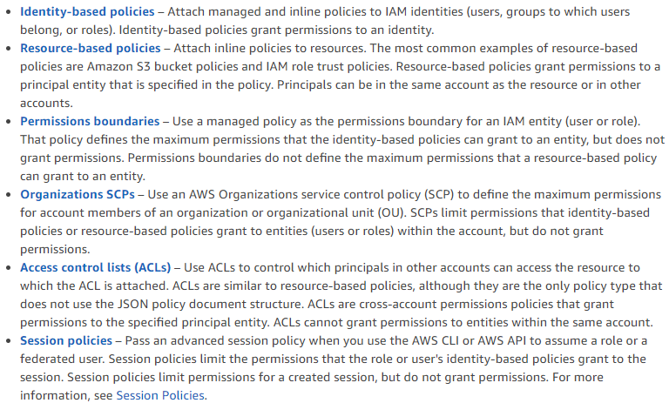

**Identity based policies:**

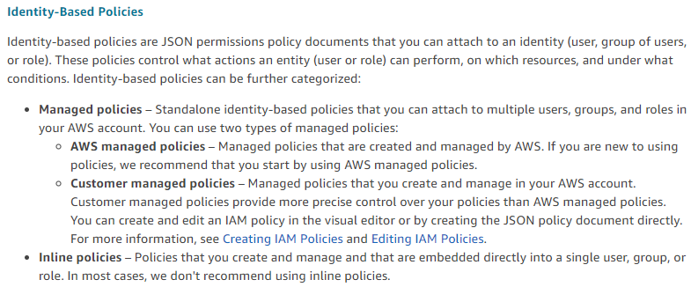

**Resource based policies:**

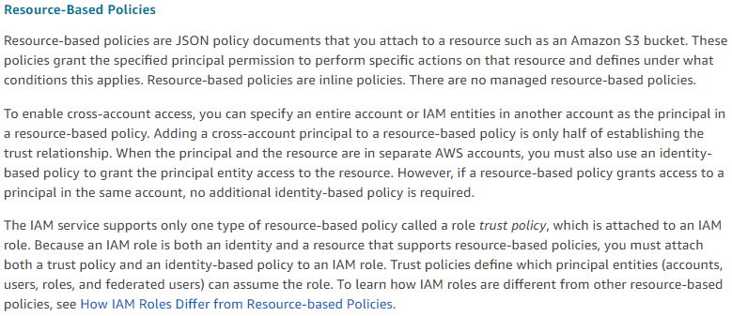

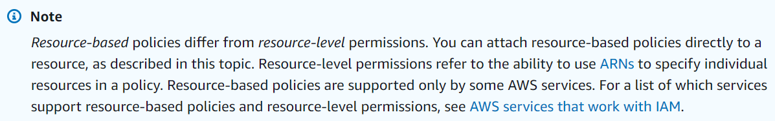

Resource level permissions are available only for some services

**IAM permission boundaries:**

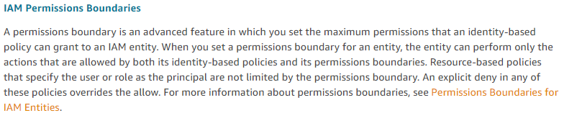

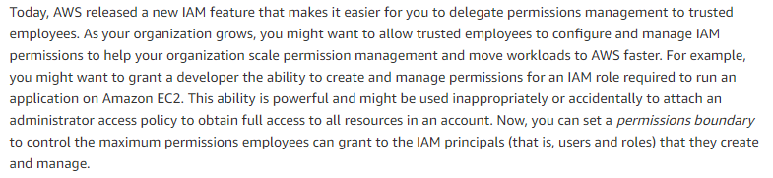

**Service control policies:**

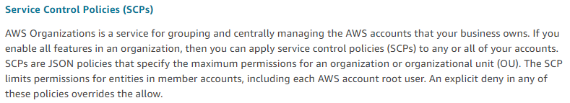

**Access control policies:**

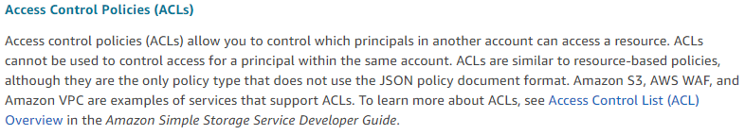

**Session policies:**

